Open Call

‘Waste Not, Want Not’ - Showroom Showcase

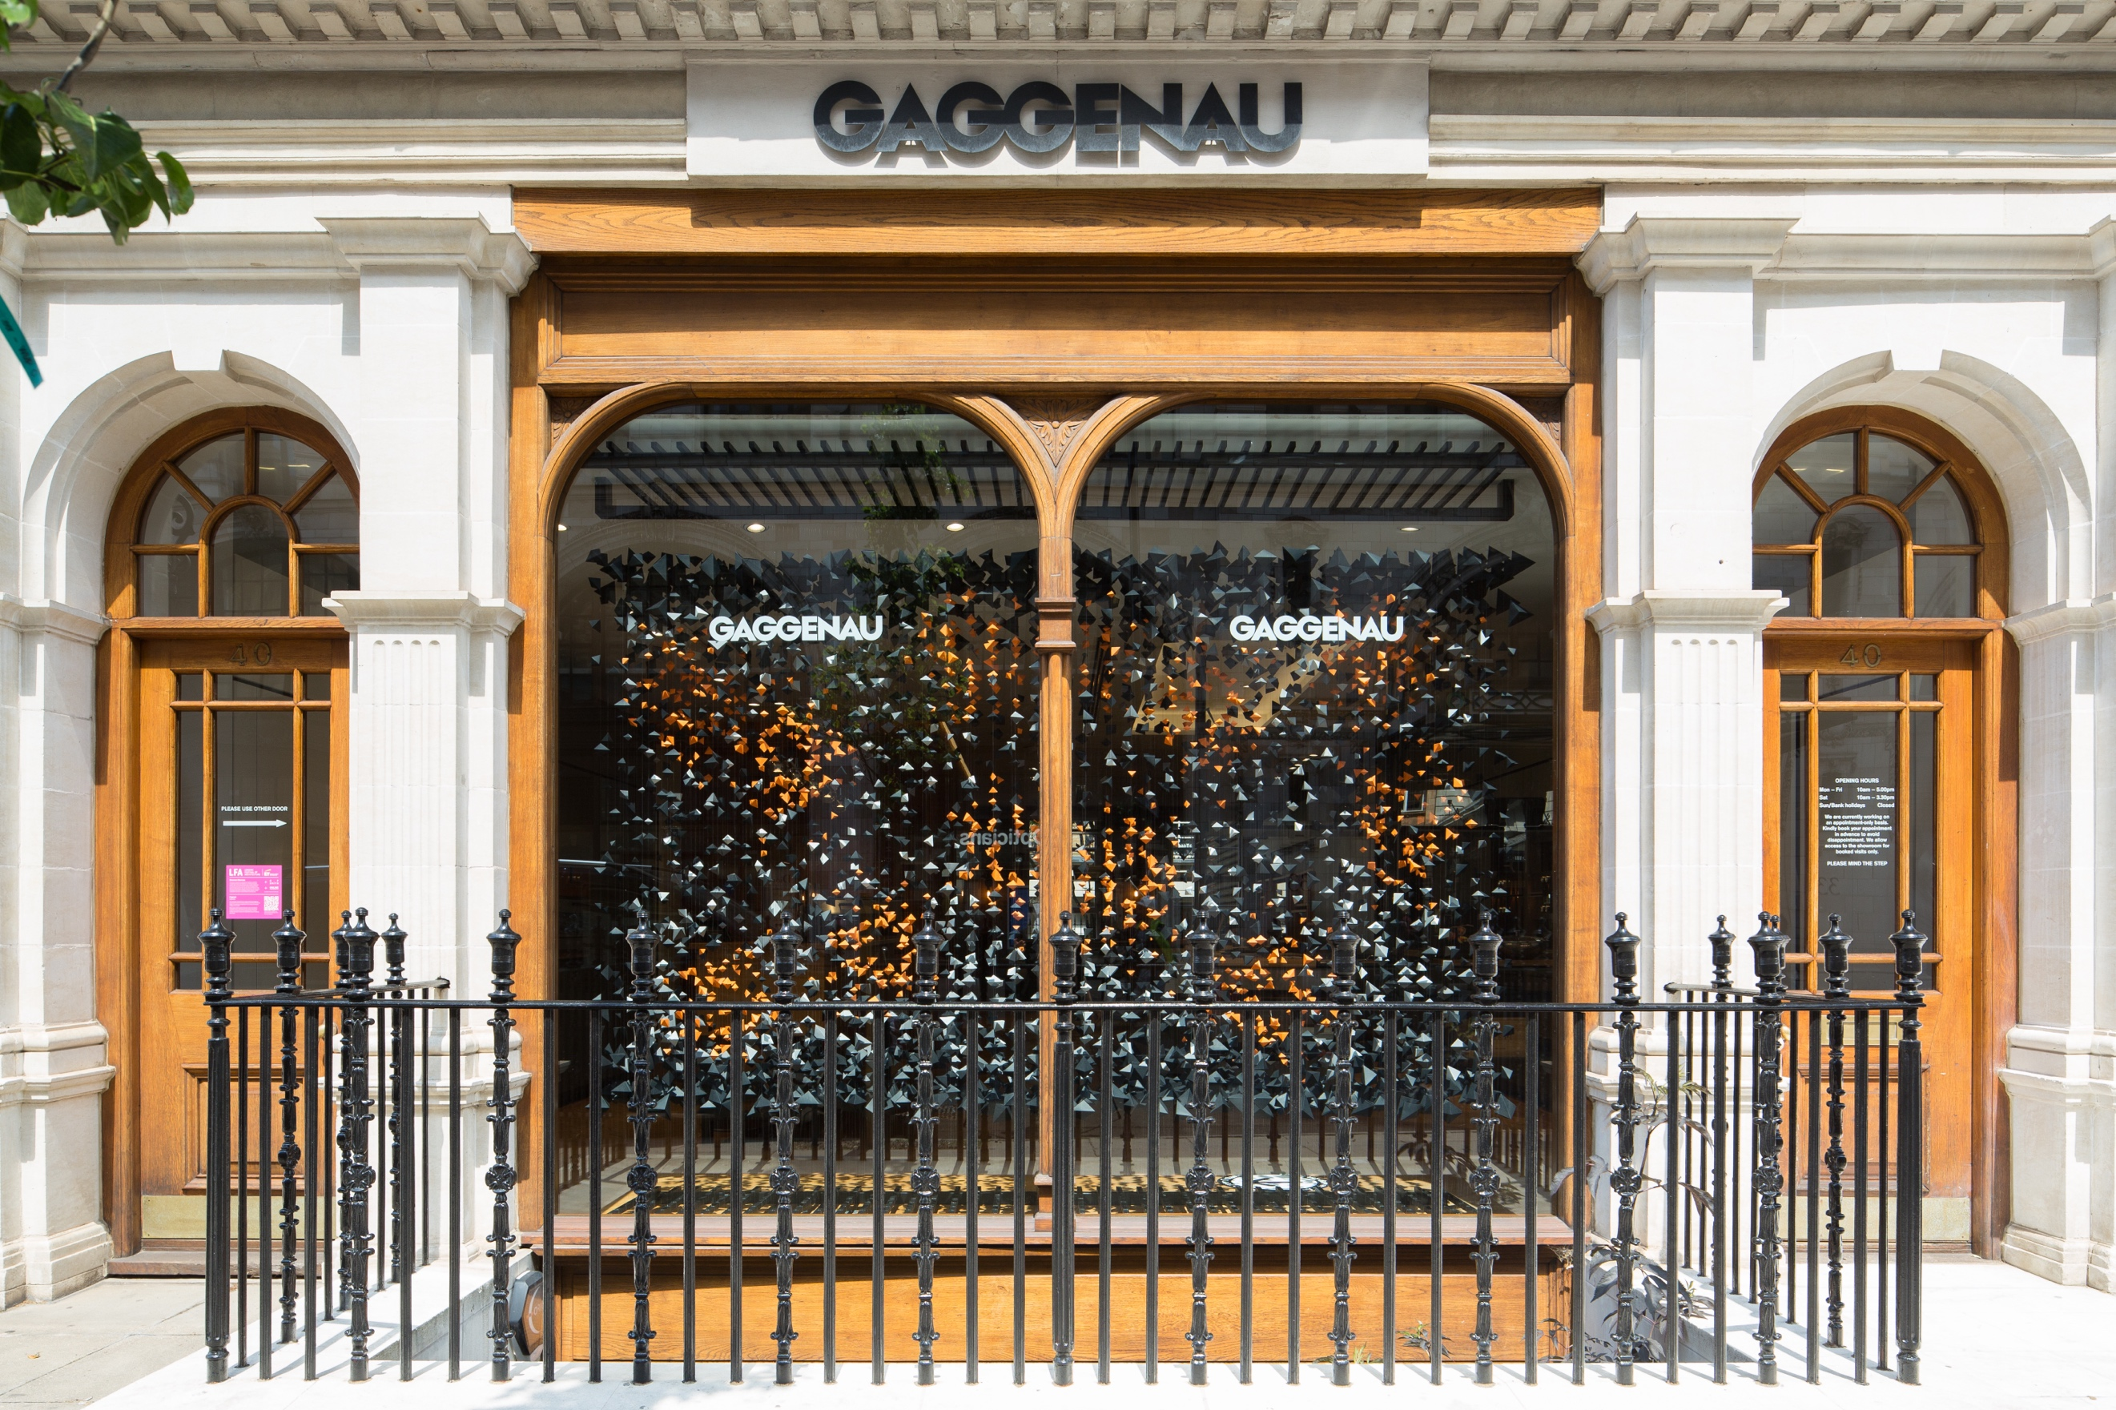

Fragment by Inclume at Gaggenau © Agnese Sanvito 2021

1

The Commission

Following on from the success of the last two years’ showroom showcase, LFA will again be partnering with some of London’s most respected brands and showcasing the work of emerging architects and designers through innovative window displays. International showrooms Gaggenau and VitrA will be taking part in the 2023 edition of Showroom Showcase, with more showrooms will be announced soon.

As part of this year’s festival, we are inviting emerging architects and designers to create unique architectural installations in showrooms across London which will be in place throughout June. As well as providing you with a window to show off your work, the LFA will showcase your work online and through a series of interviews.

This is a unique opportunity to gain a commission from a major brand and showcase your creativity and ability to produce stunning architectural interventions by re-using existing materials.

Following the competition process, winning teams will be revealed in February 2023 and will work with one of the showrooms and the London Festival of Architecture in delivering a fully costed, feasible design. Successful entrants will be awarded £1,600 (including a £600 design fee) alongside by-products from the showroom to use in making their display for London Festival of Architecture 2023.

Theme - ‘Waste not, want not’

While in the past, Showroom Showcase installations have been created using paper – in a myriad of ways – this year we’ve decided to broaden the scope of the brief to include any material that is produced as a by-product of the showroom’s manufacturing process or day-to-day activity.

The shift in focus for this competition aligns with the LFA theme ‘In Common’. A key consideration the theme looks to explore is the finite amount of natural resources we have left which need to be nurtured and sustained by us all. How can we responsibility utilise our shared resources? How can design enable us to be more efficient, less wasteful, and reduce our impact of the natural environment?

We’re inviting both the designer and the showrooms to reconsider what is deemed to be ‘waste’, to look at these more neutrally as ‘resource’ and create high-quality, striking installations that engage passers-by and spark conversation.

2
Context

The showroom showcase was originally developed to help to gain publicity and increase footfall for the brands who can been closed for significant amounts of time during lockdown. However, the success of the projects highlighted that quality design is good for business and this is a message that the LFA is keen to promote.

Although many of our installations are temporary, we aim to support sustainable design, assisting our designers and partners to plan for the afterlife of projects which go on to be re-homed or recycled.
The LFA has long worked to provide exciting opportunities for emerging architects to get exciting commissions – often their first. We hope this project will continue that tradition
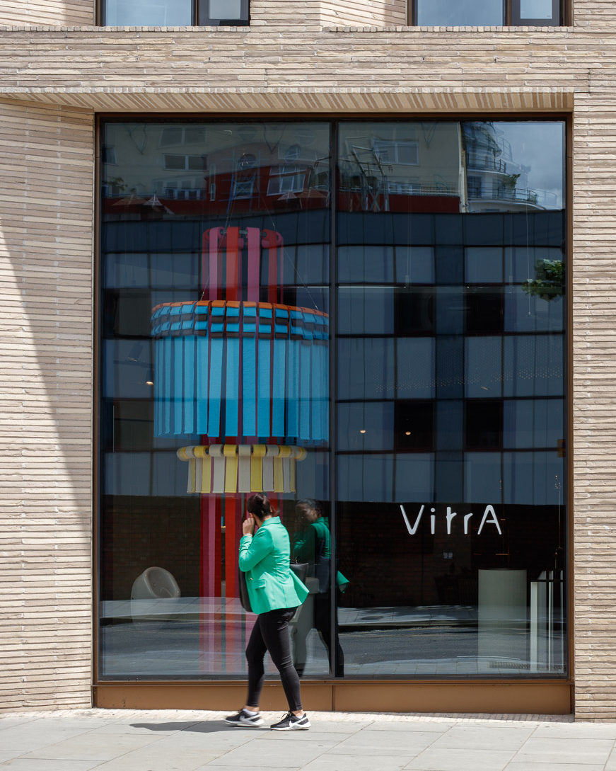
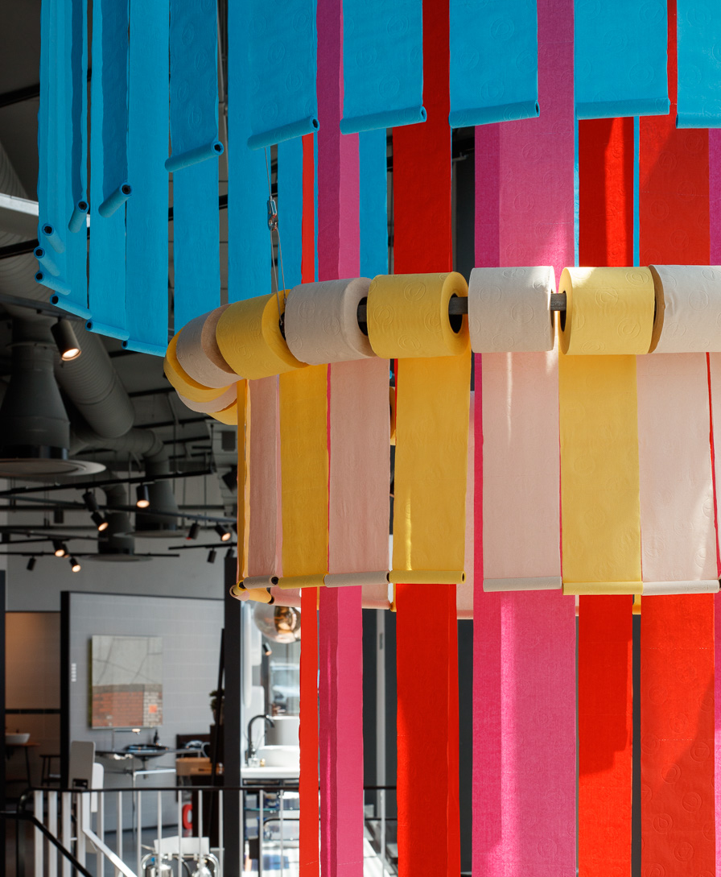
The Floating Column by Space A at VitrA Bathrooms © Luke O’Donovan

3
Working with a client

Whilst we’d like to see the installations respond to this year’s LFA theme of ‘in common’ it will be up to you to work with your showroom as the main client. You will need to identify the space available, as well as their ambitions for their window installation to agree the precise brief. The showrooms will supply the ‘waste’ material to be used in the installation.

You will be expected to work with your showroom to identify their objectives and brand priorities and then produce a worked-up design based on this for them to sign off. The LFA will also approve these to ensure they are deliverable. These designs will also be shared on the LFA website as part of the showcase of your work.

During May 2023, participating showrooms will open to allow you to install your installation. Depending on your design and your showroom, you may decide to create the installation on that day or do the production elsewhere and simply install on the day. Either way we plan on creating a buzz around the installations. We will be videoing and photographing the installation process so this can be shared digitally.

As part of our efforts to showcase your work, the LFA team will record and edit a short audio podcast with you about your design and work with the brand. These will be distributed via the LFA’s Building Sounds feed and will be accessible via an LFA window vinyl on the showroom window, allowing passers-by to scan a QR code and hear you talking about your work.

We will also video and photograph the installations, allowing for further showcasing and promotion of your work online.

Some showrooms may choose to hold an event or party in the showroom to celebrate your installation and your work and you may be invited to contribute to events as part of the festival’s programme, for example a walking trail of Showroom Showcase with designer introductions. The LFA will provide a unique window vinyl for your windows, which provides a bespoke link and QR code to the LFA website, with more information about your installation.

4
Submission

Emerging architects and designers are invited to submit a single pdf portfolio of their work - no more than 10 A4 sides (5mb maximum) – in much the same was as for our other LFA competitions. No design work is required at this initial stage, but we ask that you write a short paragraph expressing initial reflections on the brief.

The LFA team will shortlist these portfolios and present them to showrooms for them to select the architect they would like to work with. If selected, you will be notified of the showroom or brand which has selected you, and if you’re happy you’ll be paired with them to start working together on a unique display for their showroom.

The submission should include:
1. Full name and contact details including postal address, contact number and email of project lead.
2. Brief biographies of all the project team.
3. Coloured photo of the design team (landscape) for promotional purposes.
4. A 200-word description about your practice along with any relevant technical expertise acquired through previous experience; please include a selection of relevant previous work.
5. You are invited to submit a portfolio of your work – but no design at this stage.
6. A 200-word reflection on the brief including initial written reactions and your vision for the installation. In this section, please specify what type of material(s) you are interested in working with.

5
Eligibility

The competition is open to students and emerging architects, designers, engineers and artists.

Applicants need to fulfil at least two of the following criteria to be eligible for this competition:
- being no more than seven years post graduate, from your most recent qualification
- being under 40
- set up your practice / collaboration in the past three years

The judges encourage entries from, or collaborations with groups who are underrepresented in architecture.

6
Deadline and submission details

- Deadline for submission is Midday 20th January 2023. Submissions received after this time will not be considered.
- For competition enquires please contact: lydia.allainchapman@nla.london
- Please send expressions of interest in a PDF format here.
- The PDF should be no more than 5MB and 10 A4 pages.
- You will receive an email confirming receipt of your submission.

7
Schedule Outline

Submissions open: 6th December 2022
Submissions closed: Midday 20th January 2023
Winners paired with showrooms: February 2023
Architects work with showrooms to develop designs: February – May 2023
Designs signed-off and LFA audio recording: May 2023
Installation constructed/installed: before 31st May 2023
Installation removed: To be agreed with Showroom

8
Further information

- The ownership of Copyright of the design will be in accordance with the Copyright, Designs and Patents Act 1988, that is Copyright rests with the author of the submitted design.
- All applicants will be notified of the outcomes, but due to the volume of applications we may not be able to provide feedback to entrants individually.
- All designs remain the intellectual property of the designer however the winning designs when built, will be the property of the partnered showroom.
- Please bear in mind that the project requires a fast turn around and may have peak moments when your practice will need to dedicate sufficient staff to deliver the project on time, on budget and to the high standard expected by all stakeholders.
- Significant efforts are made by all stakeholders of the project to ensure wide media coverage.
- The London Festival of Architecture and partnered showrooms reserves the right to use images from the submissions for promotional purposes in press, social media and publications. All endeavours will be made to ensure accurate accreditation.

9
Contact

To submit your entry please go here.

For general enquires please contact: lydia.allainchapman@nla.london

10
Disclaimer

The competition organisers are not liable for lost, misdirected, or late entries. The selection of submissions is based on professional judgments by the festival team and the partnered showrooms and all decisions are final. While it is the intent to construct the winning scheme, the organisers reserve the right to not proceed with construction for any reason. Material submitted by you shall be your sole responsibility, shall not infringe or violate the rights of any other party or violate any laws, contribute to or encourage infringing or otherwise unlawful conduct, or otherwise be obscene, objectionable, or in poor taste. By submitting such material, you are representing that you are the owner of such material and/or have all necessary rights, licenses, and authorization to distribute it.

11
London Festival of Architecture

The London Festival of Architecture (LFA) is a month-long celebration of architecture and city-making, taking place every June across London. The Festival’s mission is to open up discussions around architecture, test new ideas and promote emerging talent. The Festival brings together the public and built environment professionals for the whole month of June and seeks to inspire and engage our audience with a programme that showcases London as a global architecture hub. LFA is run by New London Architecture (NLA), the world’s leading centre for the built environment industry.

www.londonfestivalofarchitecture.org
Twitter: @LFArchitecture

12
Reference

View the winning designs for Showroom Showcase 2022

View the winning designs for Showroom Showcase 2021

